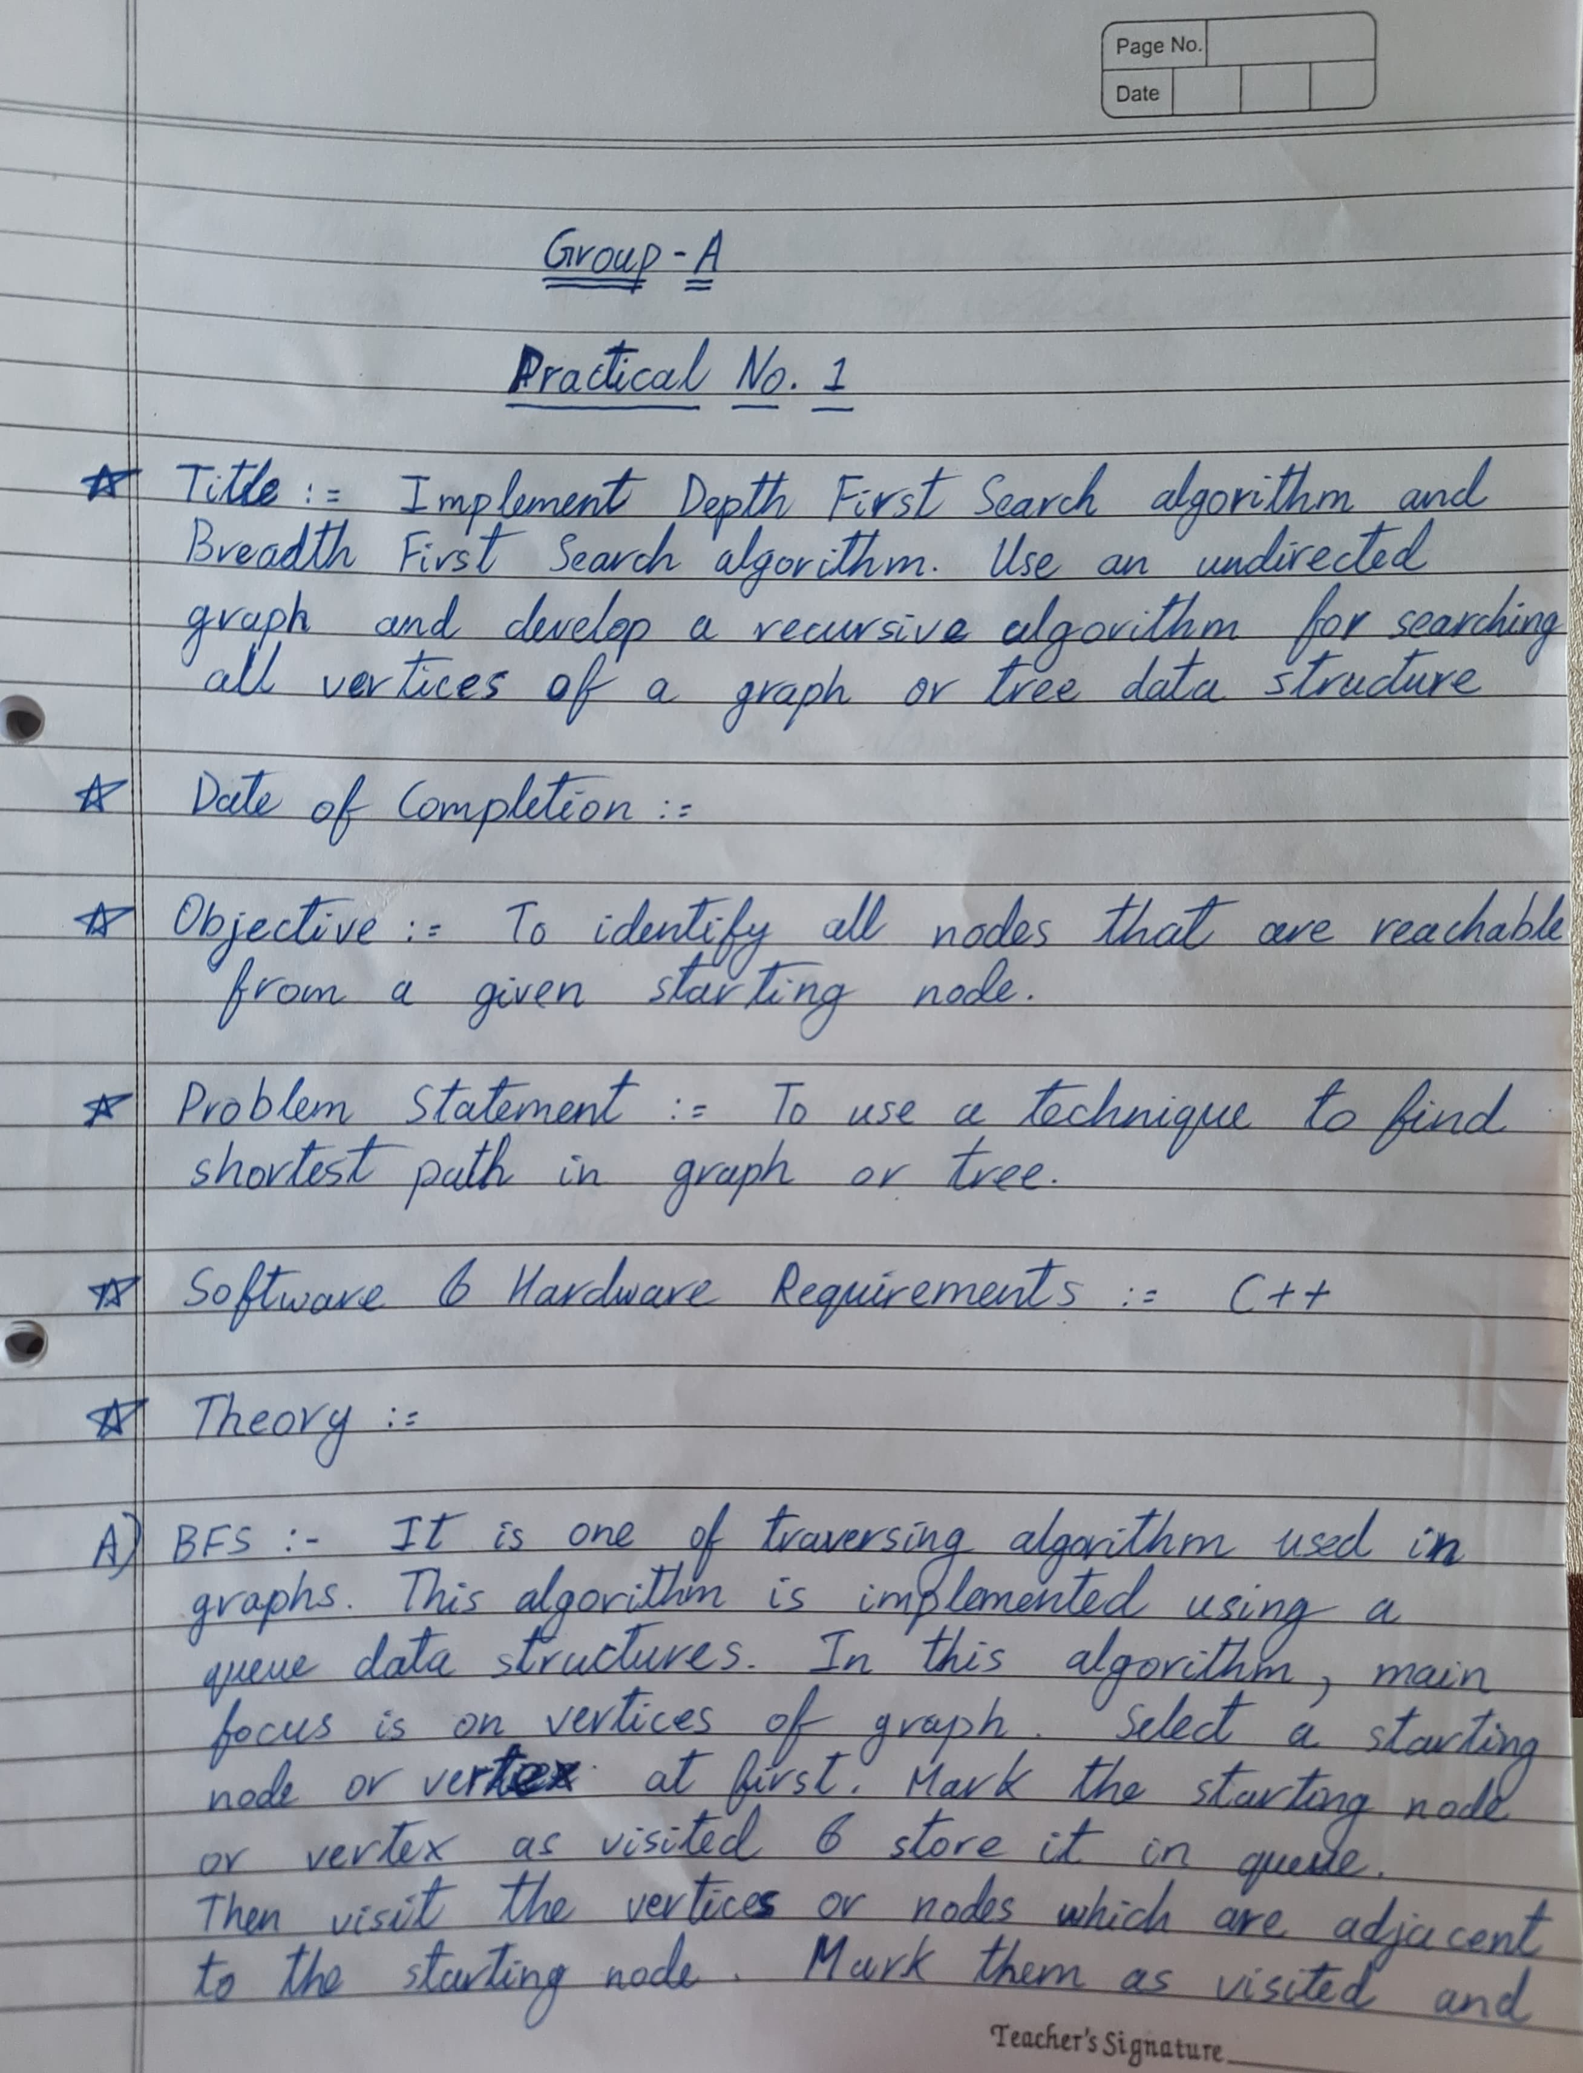

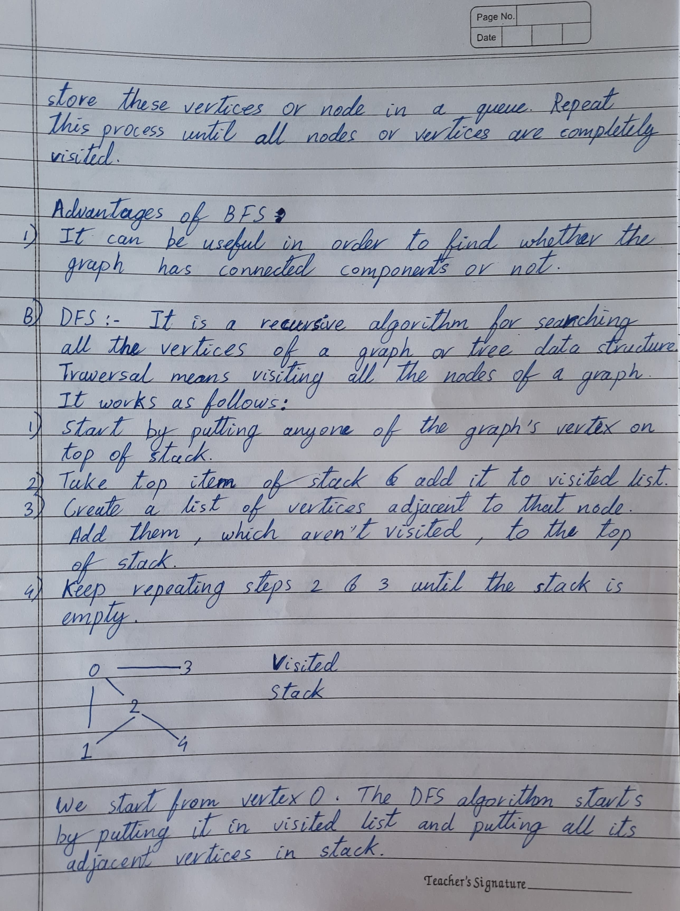

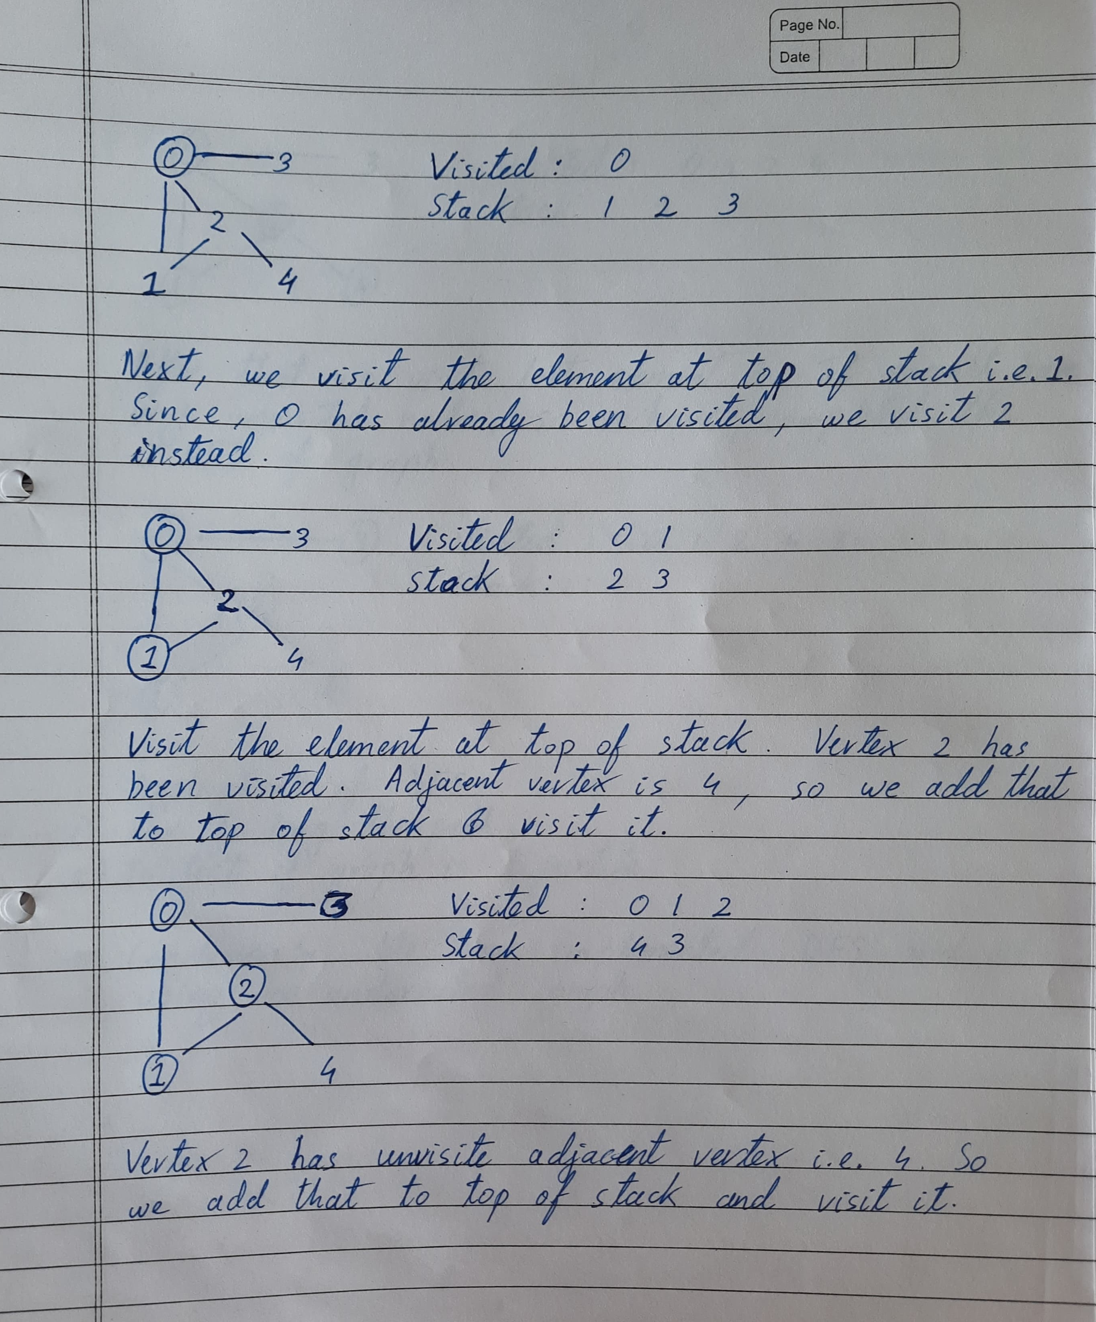

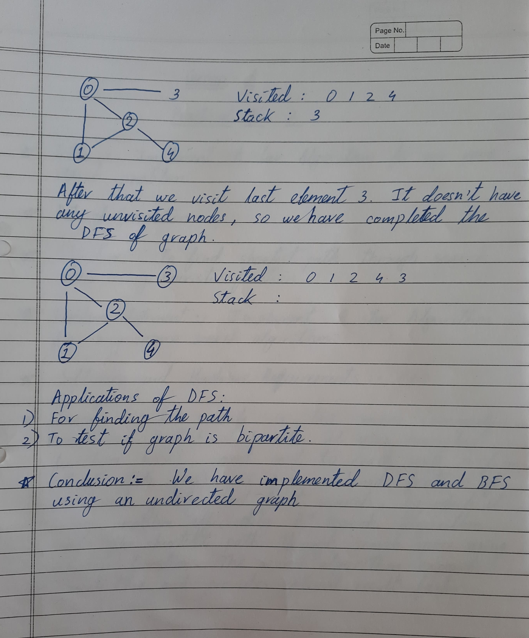

Practical No. A1

Que :- Implement Depth First Search algorithm and Breadth First algorithm. Use an undirected graph and develop a recursive algorithm for searching all the vertices of the graph or tree data structure.

Solution :-

1. Depth First search :

Input =>

#include <iostream>

#include <map>

#include <list>

using namespace std;

class Graph {

public:

map<int, bool> visited;

map<int, list<int> > adj;

void addEdge(int v, int w);

void DFS(int v);

};

void Graph::addEdge(int v, int w) {

adj[v].push_back(w);

}

void Graph::DFS(int v) {

visited[v] = true;

cout << v << " ";

list<int>::iterator i;

for (i = adj[v].begin(); i != adj[v].end(); ++i)

if (!visited[*i])

DFS(*i);

}

int main() {

Graph g;

g.addEdge(0, 1);

g.addEdge(0, 2);

g.addEdge(1, 2);

g.addEdge(2, 0);

g.addEdge(2, 3);

g.addEdge(3, 3);

cout << "Following is Depth First Traversal (starting from vertex 2) \n";

g.DFS(2);

return 0;

}

Output =>

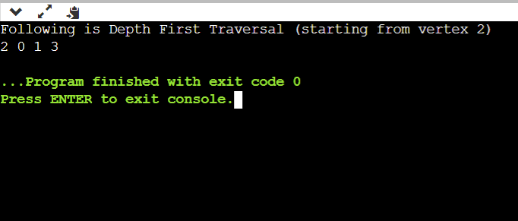

2. Breadth First Search :

Input =>

#include<iostream>

#include <list>

using namespace std;

class Graph {

int V;

list < int >*adj;

public:

Graph (int V);

void addEdge (int v, int w);

void BFS (int s);

};

Graph::Graph (int V) {

this->V = V;

adj = new list < int >[V];

}

void Graph::addEdge (int v, int w) {

adj[v].push_back (w);

}

void Graph::BFS (int s) {

bool * visited = new bool[V];

for (int i = 0; i < V; i++)

visited[i] = false;

list < int >queue;

visited[s] = true;

queue.push_back (s);

list < int >::iterator i;

while (!queue.empty ()) {

s = queue.front ();

cout << s << " ";

queue.pop_front ();

for (i = adj[s].begin (); i != adj[s].end (); ++i) {

if (!visited[*i]) {

visited[*i] = true;

queue.push_back (*i);

}

}

}

}

int main () {

Graph g (4);

g.addEdge (0, 1);

g.addEdge (0, 2);

g.addEdge (1, 2);

g.addEdge (2, 0);

g.addEdge (2, 3);

g.addEdge (3, 3);

cout << "Following is Breadth First Traversal (starting from vertex 2) \n";

g.BFS (2);

return 0;

}

Output =>

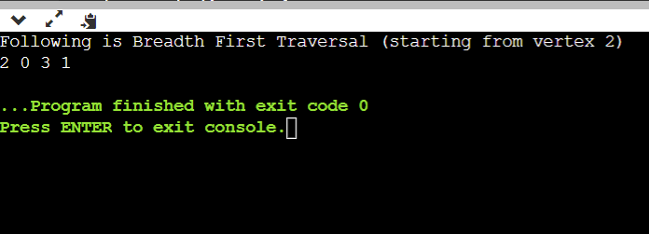

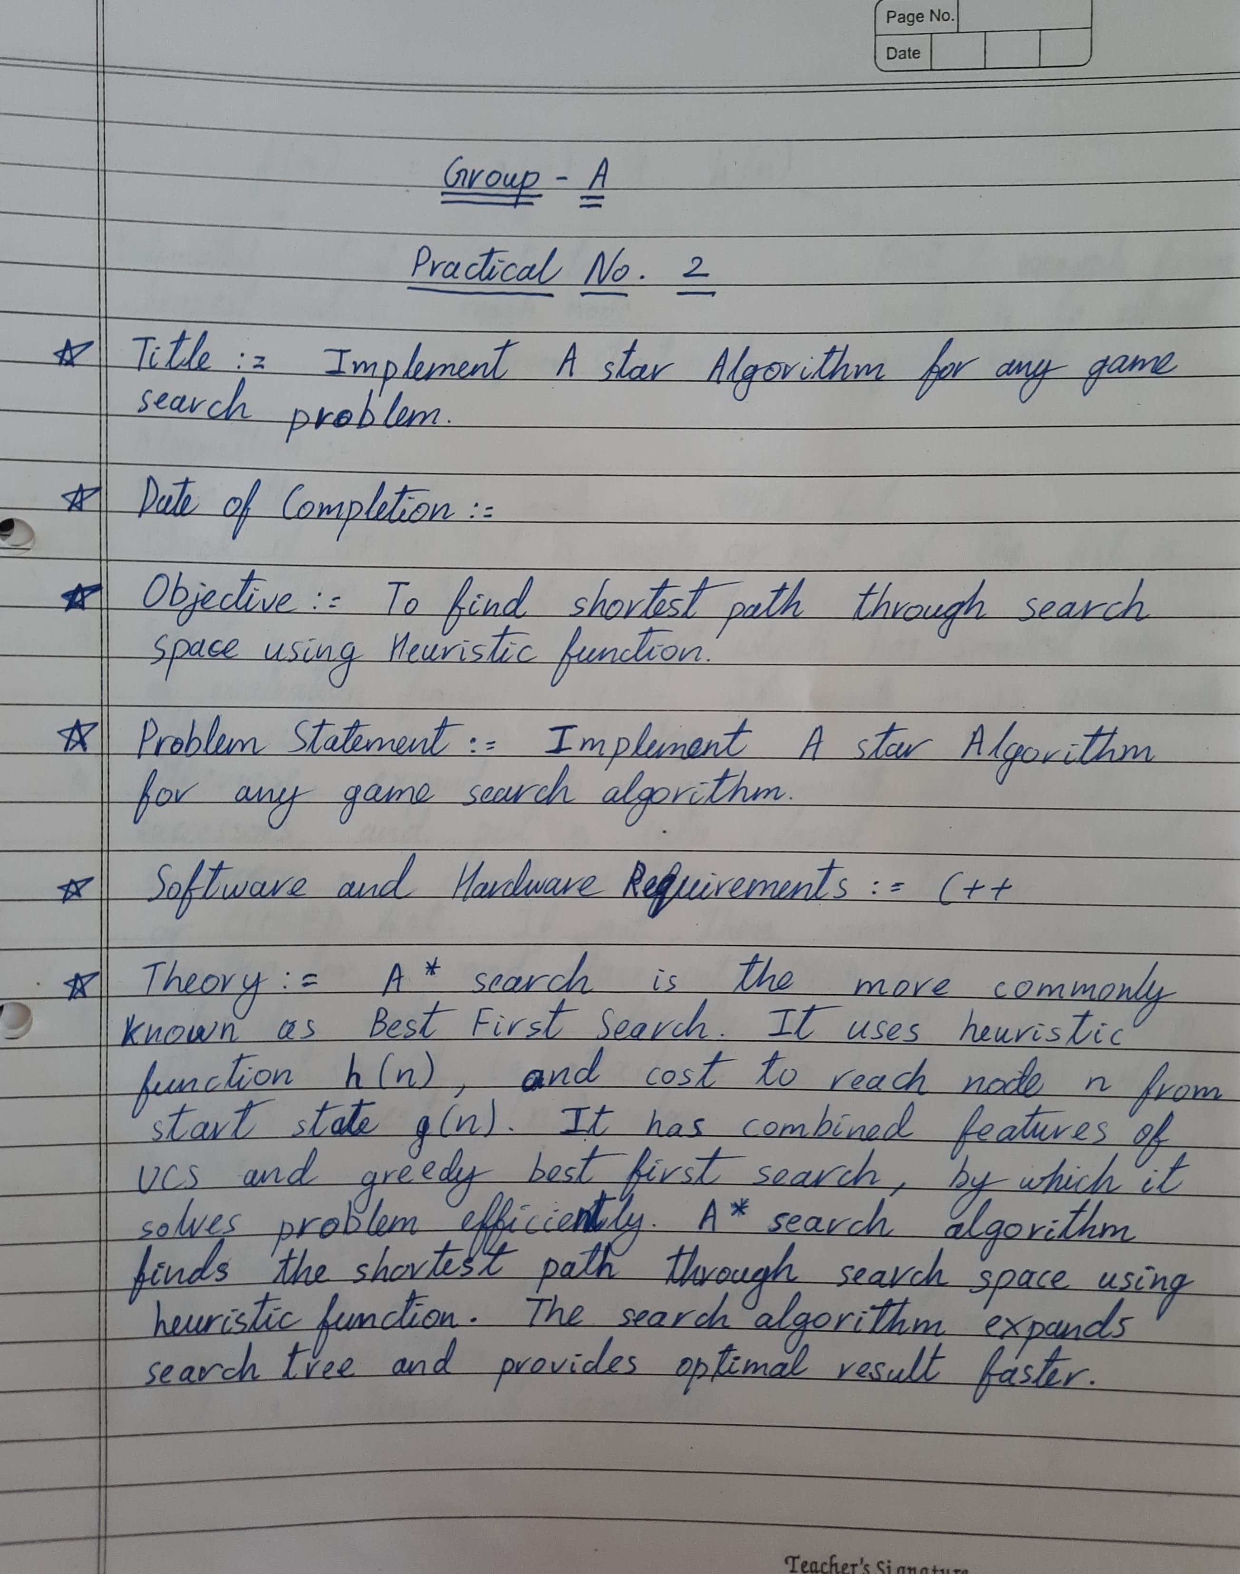

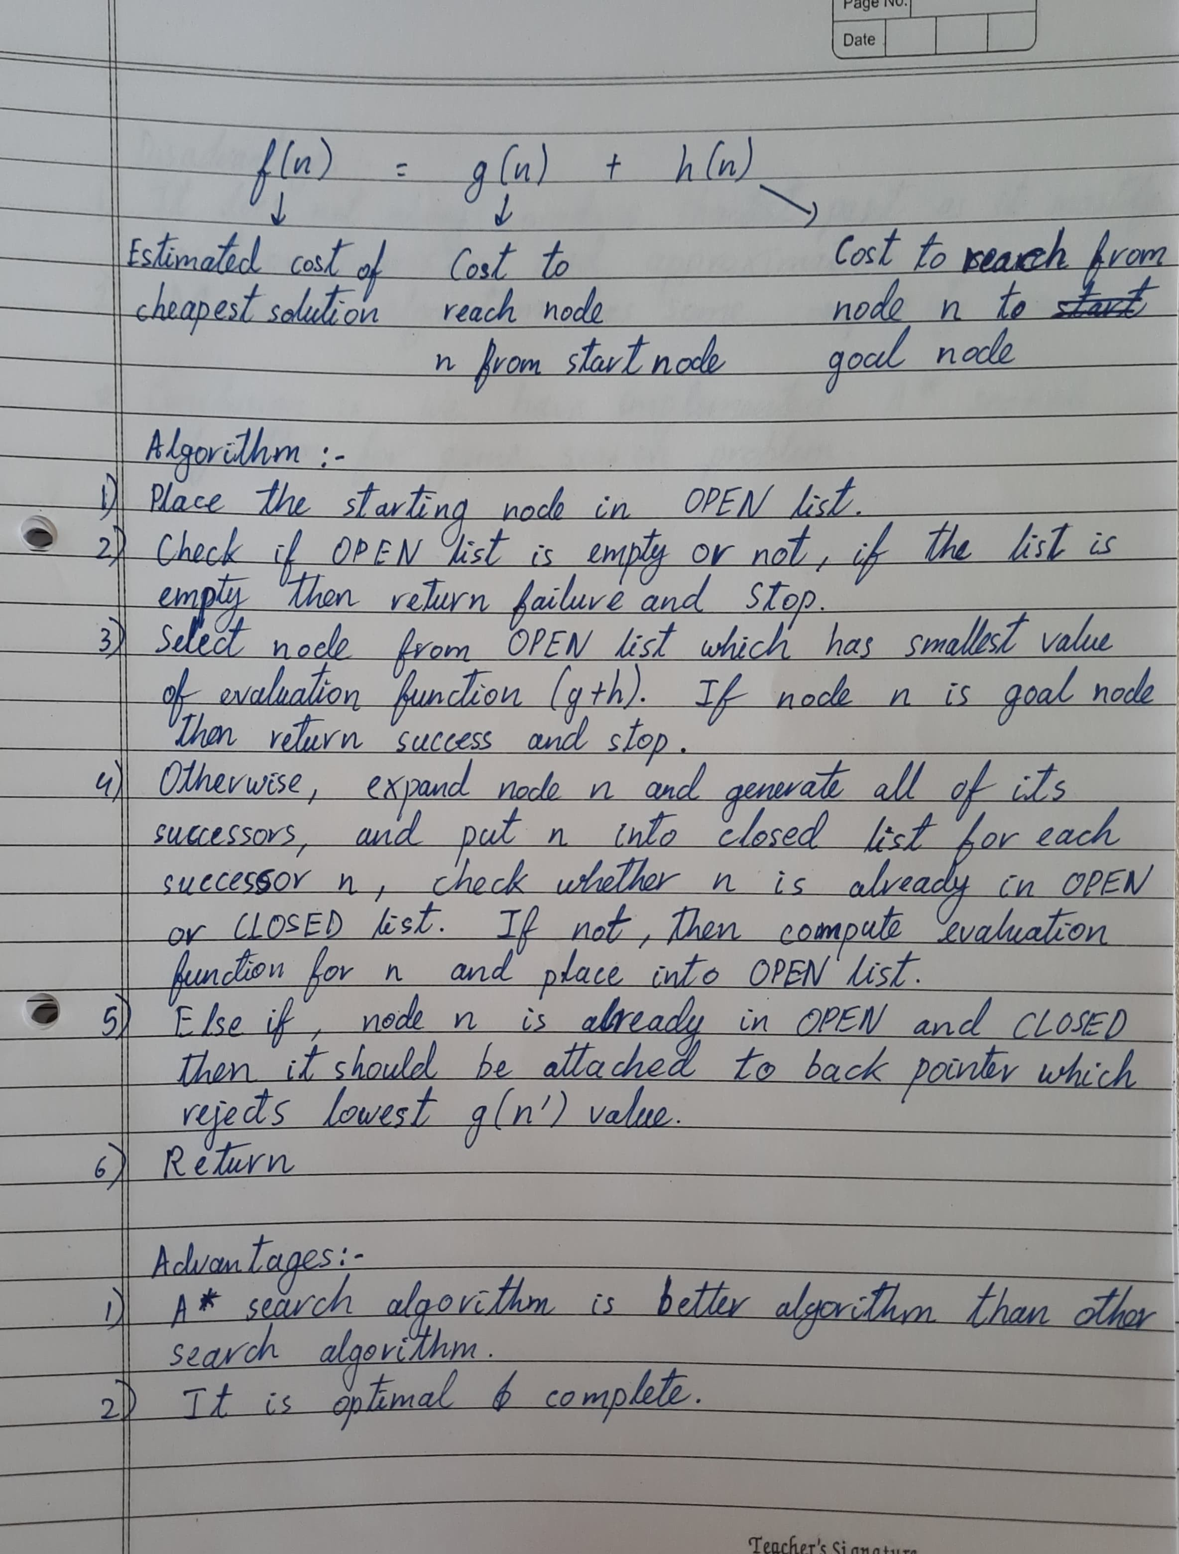

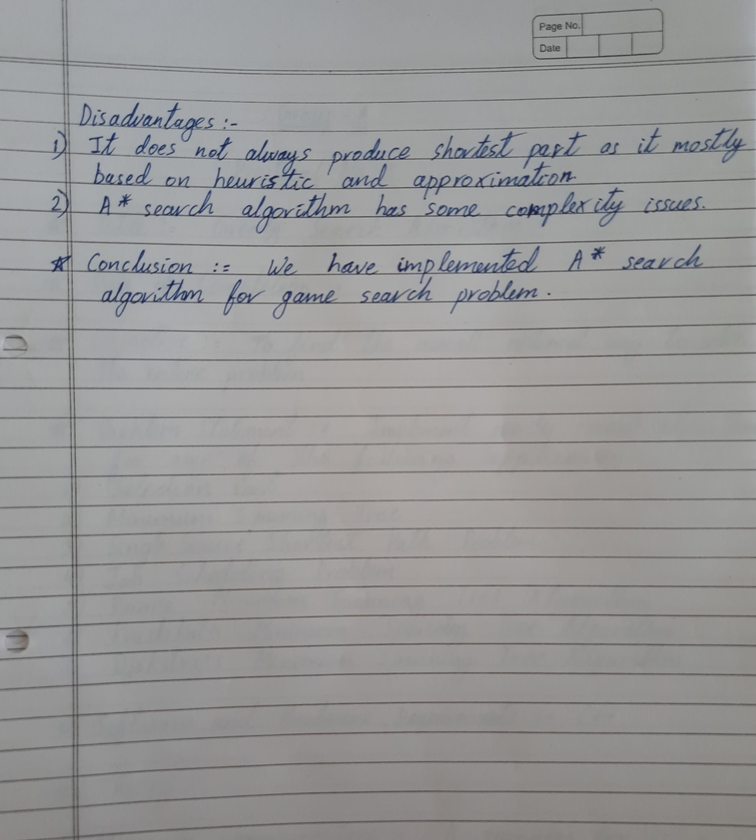

Practical No. A2

Que :- Implement A star Algorithm for any game search problem.

Solution :-

Input =>

#include <bits/stdc++.h>

using namespace std;

#define ROW 9

#define COL 10

typedef pair < int, int > Pair;

typedef pair < double, pair < int, int >> pPair;

struct cell {

int parent_i, parent_j;

double f, g, h;

};

bool isValid (int row, int col) {

return (row >= 0) && (row < ROW) && (col >= 0) && (col < COL);

}

bool isUnBlocked (int grid[][COL], int row, int col) {

if (grid[row][col] == 1)

return (true);

else

return (false);

}

bool isDestination (int row, int col, Pair dest) {

if (row == dest.first && col == dest.second)

return (true);

else

return (false);

}

double calculateHValue (int row, int col, Pair dest) {

return ((double) sqrt ((row - dest.first) * (row - dest.first)+(col - dest.second) * (col - dest.second)));

}

void tracePath (cell cellDetails[][COL], Pair dest) {

printf ("\nThe Path is ");

int row = dest.first;

int col = dest.second;

stack < Pair > Path;

while (!(cellDetails[row][col].parent_i == row && cellDetails[row][col].parent_j == col)) {

Path.push (make_pair (row, col));

int temp_row = cellDetails[row][col].parent_i;

int temp_col = cellDetails[row][col].parent_j;

row = temp_row;

col = temp_col;

}

Path.push (make_pair (row, col));

while (!Path.empty ()) {

pair < int, int >p = Path.top ();

Path.pop ();

printf ("-> (%d,%d) ", p.first, p.second);

}

return;

}

void aStarSearch (int grid[][COL], Pair src, Pair dest) {

if (isValid (src.first, src.second) == false) {

printf ("Source is invalid\n");

return;

}

if (isValid (dest.first, dest.second) == false) {

printf ("Destination is invalid\n");

return;

}

if (isUnBlocked (grid, src.first, src.second) == false || isUnBlocked (grid, dest.first, dest.second) == false) {

printf ("Source or the destination is blocked\n");

return;

}

if (isDestination (src.first, src.second, dest) == true) {

printf ("We are already at the destination\n");

return;

}

bool closedList[ROW][COL];

memset (closedList, false, sizeof (closedList));

cell cellDetails[ROW][COL];

int i, j;

for (i = 0; i < ROW; i++) {

for (j = 0; j < COL; j++) {

cellDetails[i][j].f = FLT_MAX;

cellDetails[i][j].g = FLT_MAX;

cellDetails[i][j].h = FLT_MAX;

cellDetails[i][j].parent_i = -1;

cellDetails[i][j].parent_j = -1;

}

}

i = src.first, j = src.second;

cellDetails[i][j].f = 0.0;

cellDetails[i][j].g = 0.0;

cellDetails[i][j].h = 0.0;

cellDetails[i][j].parent_i = i;

cellDetails[i][j].parent_j = j;

set < pPair > openList;

openList.insert (make_pair (0.0, make_pair (i, j)));

bool foundDest = false;

while (!openList.empty ()) {

pPair p = *openList.begin ();

openList.erase (openList.begin ());

i = p.second.first;

j = p.second.second;

closedList[i][j] = true;

double gNew, hNew, fNew;

if (isValid (i - 1, j) == true) {

if (isDestination (i - 1, j, dest) == true) {

cellDetails[i - 1][j].parent_i = i;

cellDetails[i - 1][j].parent_j = j;

printf ("The destination cell is found\n");

tracePath (cellDetails, dest);

foundDest = true;

return;

}

else if (closedList[i - 1][j] == false && isUnBlocked (grid, i - 1, j) == true) {

gNew = cellDetails[i][j].g + 1.0;

hNew = calculateHValue (i - 1, j, dest);

fNew = gNew + hNew;

if (cellDetails[i - 1][j].f == FLT_MAX || cellDetails[i - 1][j].f > fNew) {

openList.insert (make_pair (

fNew, make_pair (i - 1, j)));

cellDetails[i - 1][j].f = fNew;

cellDetails[i - 1][j].g = gNew;

cellDetails[i - 1][j].h = hNew;

cellDetails[i - 1][j].parent_i = i;

cellDetails[i - 1][j].parent_j = j;

}

}

}

if (isValid (i + 1, j) == true) {

if (isDestination (i + 1, j, dest) == true) {

cellDetails[i + 1][j].parent_i = i;

cellDetails[i + 1][j].parent_j = j;

printf ("The destination cell is found\n");

tracePath (cellDetails, dest);

foundDest = true;

return;

}

else if (closedList[i + 1][j] == false && isUnBlocked (grid, i + 1, j) == true) {

gNew = cellDetails[i][j].g + 1.0;

hNew = calculateHValue (i + 1, j, dest);

fNew = gNew + hNew;

if (cellDetails[i + 1][j].f == FLT_MAX || cellDetails[i + 1][j].f > fNew) {

openList.insert (make_pair(fNew, make_pair (i + 1, j)));

cellDetails[i + 1][j].f = fNew;

cellDetails[i + 1][j].g = gNew;

cellDetails[i + 1][j].h = hNew;

cellDetails[i + 1][j].parent_i = i;

cellDetails[i + 1][j].parent_j = j;

}

}

}

if (isValid (i, j + 1) == true) {

if (isDestination (i, j + 1, dest) == true) {

cellDetails[i][j + 1].parent_i = i;

cellDetails[i][j + 1].parent_j = j;

printf ("The destination cell is found\n");

tracePath (cellDetails, dest);

foundDest = true;

return;

}

else if (closedList[i][j + 1] == false && isUnBlocked (grid, i, j + 1) == true) {

gNew = cellDetails[i][j].g + 1.0;

hNew = calculateHValue (i, j + 1, dest);

fNew = gNew + hNew;

if (cellDetails[i][j + 1].f == FLT_MAX || cellDetails[i][j + 1].f > fNew) {

openList.insert (make_pair(fNew, make_pair (i, j + 1)));

cellDetails[i][j + 1].f = fNew;

cellDetails[i][j + 1].g = gNew;

cellDetails[i][j + 1].h = hNew;

cellDetails[i][j + 1].parent_i = i;

cellDetails[i][j + 1].parent_j = j;

}

}

}

if (isValid(i, j - 1) == true)

{

if (isDestination(i, j - 1, dest) == true)

{

cellDetails[i][j - 1].parent_i = i;

cellDetails[i][j - 1].parent_j = j;

printf("The destination cell is found\n");

tracePath(cellDetails, dest);

foundDest = true;

return;

}

else if (closedList[i][j - 1] == false && isUnBlocked(grid, i, j - 1) == true)

{

gNew = cellDetails[i][j].g + 1.0;

hNew = calculateHValue(i, j - 1, dest);

fNew = gNew + hNew;

if (cellDetails[i][j - 1].f == FLT_MAX || cellDetails[i][j - 1].f > fNew)

{

openList.insert(make_pair(fNew, make_pair(i, j - 1)));

cellDetails[i][j - 1].f = fNew;

cellDetails[i][j - 1].g = gNew;

cellDetails[i][j - 1].h = hNew;

cellDetails[i][j - 1].parent_i = i;

cellDetails[i][j - 1].parent_j = j;

}

}

}

if (isValid(i - 1, j + 1) == true)

{

if (isDestination(i - 1, j + 1, dest) == true)

{

cellDetails[i - 1][j + 1].parent_i = i;

cellDetails[i - 1][j + 1].parent_j = j;

printf("The destination cell is found\n");

tracePath(cellDetails, dest);

foundDest = true;

return;

}

else if (closedList[i - 1][j + 1] == false && isUnBlocked(grid, i - 1, j + 1) == true)

{

gNew = cellDetails[i][j].g + 1.414;

hNew = calculateHValue(i - 1, j + 1, dest);

fNew = gNew + hNew;

if (cellDetails[i - 1][j + 1].f == FLT_MAX || cellDetails[i - 1][j + 1].f > fNew)

{

openList.insert(make_pair(fNew, make_pair(i - 1, j + 1)));

cellDetails[i - 1][j + 1].f = fNew;

cellDetails[i - 1][j + 1].g = gNew;

cellDetails[i - 1][j + 1].h = hNew;

cellDetails[i - 1][j + 1].parent_i = i;

cellDetails[i - 1][j + 1].parent_j = j;

}

}

}

if (isValid(i - 1, j - 1) == true)

{

if (isDestination(i - 1, j - 1, dest) == true)

{

cellDetails[i - 1][j - 1].parent_i = i;

cellDetails[i - 1][j - 1].parent_j = j;

printf("The destination cell is found\n");

tracePath(cellDetails, dest);

foundDest = true;

return;

}

else if (closedList[i - 1][j - 1] == false && isUnBlocked(grid, i - 1, j - 1) == true)

{

gNew = cellDetails[i][j].g + 1.414;

hNew = calculateHValue(i - 1, j - 1, dest);

fNew = gNew + hNew;

if (cellDetails[i - 1][j - 1].f == FLT_MAX || cellDetails[i - 1][j - 1].f > fNew)

{

openList.insert(make_pair(fNew, make_pair(i - 1, j - 1)));

cellDetails[i - 1][j - 1].f = fNew;

cellDetails[i - 1][j - 1].g = gNew;

cellDetails[i - 1][j - 1].h = hNew;

cellDetails[i - 1][j - 1].parent_i = i;

cellDetails[i - 1][j - 1].parent_j = j;

}

}

}

if (isValid(i + 1, j + 1) == true)

{

if (isDestination(i + 1, j + 1, dest) == true)

{

cellDetails[i + 1][j + 1].parent_i = i;

cellDetails[i + 1][j + 1].parent_j = j;

printf("The destination cell is found\n");

tracePath(cellDetails, dest);

foundDest = true;

return;

}

else if (closedList[i + 1][j + 1] == false && isUnBlocked(grid, i + 1, j + 1) == true)

{

gNew = cellDetails[i][j].g + 1.414;

hNew = calculateHValue(i + 1, j + 1, dest);

fNew = gNew + hNew;

if (cellDetails[i + 1][j + 1].f == FLT_MAX || cellDetails[i + 1][j + 1].f > fNew)

{

openList.insert(make_pair(fNew, make_pair(i + 1, j + 1)));

cellDetails[i + 1][j + 1].f = fNew;

cellDetails[i + 1][j + 1].g = gNew;

cellDetails[i + 1][j + 1].h = hNew;

cellDetails[i + 1][j + 1].parent_i = i;

cellDetails[i + 1][j + 1].parent_j = j;

}

}

}

if (isValid(i + 1, j - 1) == true)

{

if (isDestination(i + 1, j - 1, dest) == true)

{

cellDetails[i + 1][j - 1].parent_i = i;

cellDetails[i + 1][j - 1].parent_j = j;

printf("The destination cell is found\n");

tracePath(cellDetails, dest);

foundDest = true;

return;

}

else if (closedList[i + 1][j - 1] == false && isUnBlocked(grid, i + 1, j - 1) == true)

{

gNew = cellDetails[i][j].g + 1.414;

hNew = calculateHValue(i + 1, j - 1, dest);

fNew = gNew + hNew;

if (cellDetails[i + 1][j - 1].f == FLT_MAX || cellDetails[i + 1][j - 1].f > fNew)

{

openList.insert(make_pair(fNew, make_pair(i + 1, j - 1)));

cellDetails[i + 1][j - 1].f = fNew;

cellDetails[i + 1][j - 1].g = gNew;

cellDetails[i + 1][j - 1].h = hNew;

cellDetails[i + 1][j - 1].parent_i = i;

cellDetails[i + 1][j - 1].parent_j = j;

}

}

}

}

if (foundDest == false)

printf("Failed to find the Destination Cell\n");

return;

}

int main()

{

int grid[ROW][COL] = {

{ 1, 0, 1, 1, 1, 1, 0, 1, 1, 1 },

{ 1, 1, 1, 0, 1, 1, 1, 0, 1, 1 },

{ 1, 1, 1, 0, 1, 1, 0, 1, 0, 1 },

{ 0, 0, 1, 0, 1, 0, 0, 0, 0, 1 },

{ 1, 1, 1, 0, 1, 1, 1, 0, 1, 0 },

{ 1, 0, 1, 1, 1, 1, 0, 1, 0, 0 },

{ 1, 0, 0, 0, 0, 1, 0, 0, 0, 1 },

{ 1, 0, 1, 1, 1, 1, 0, 1, 1, 1 },

{ 1, 1, 1, 0, 0, 0, 1, 0, 0, 1 }

};

Pair src = make_pair(8, 0);

Pair dest = make_pair(0, 0);

aStarSearch(grid, src, dest);

return (0);

}

Output =>

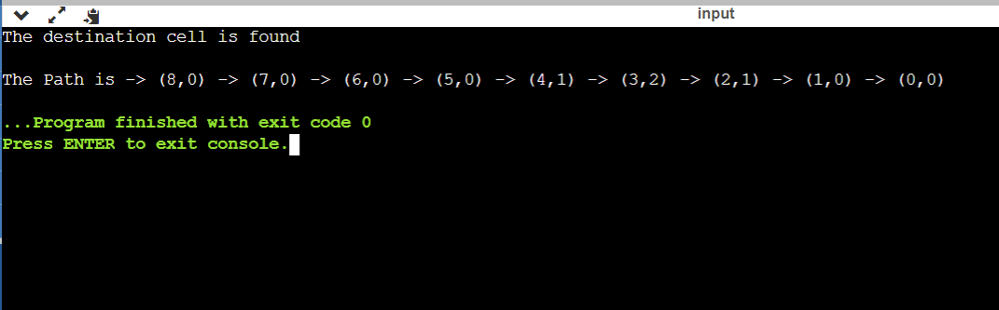

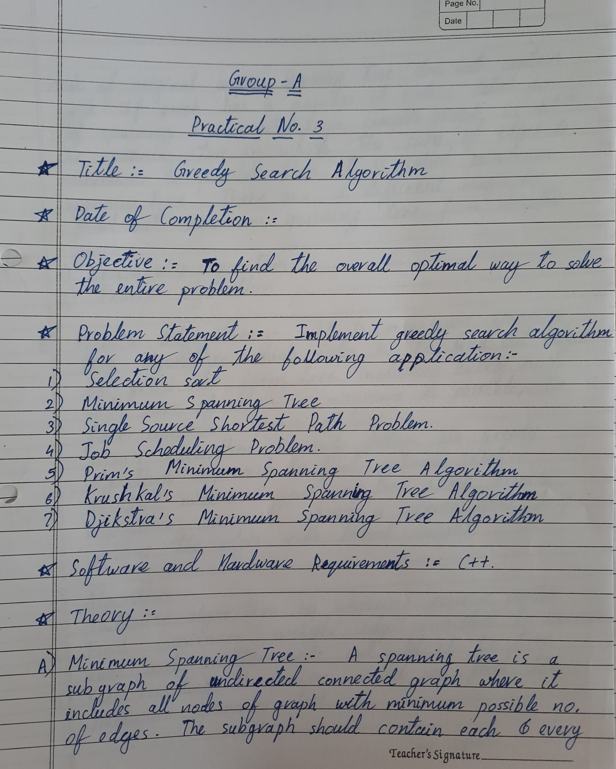

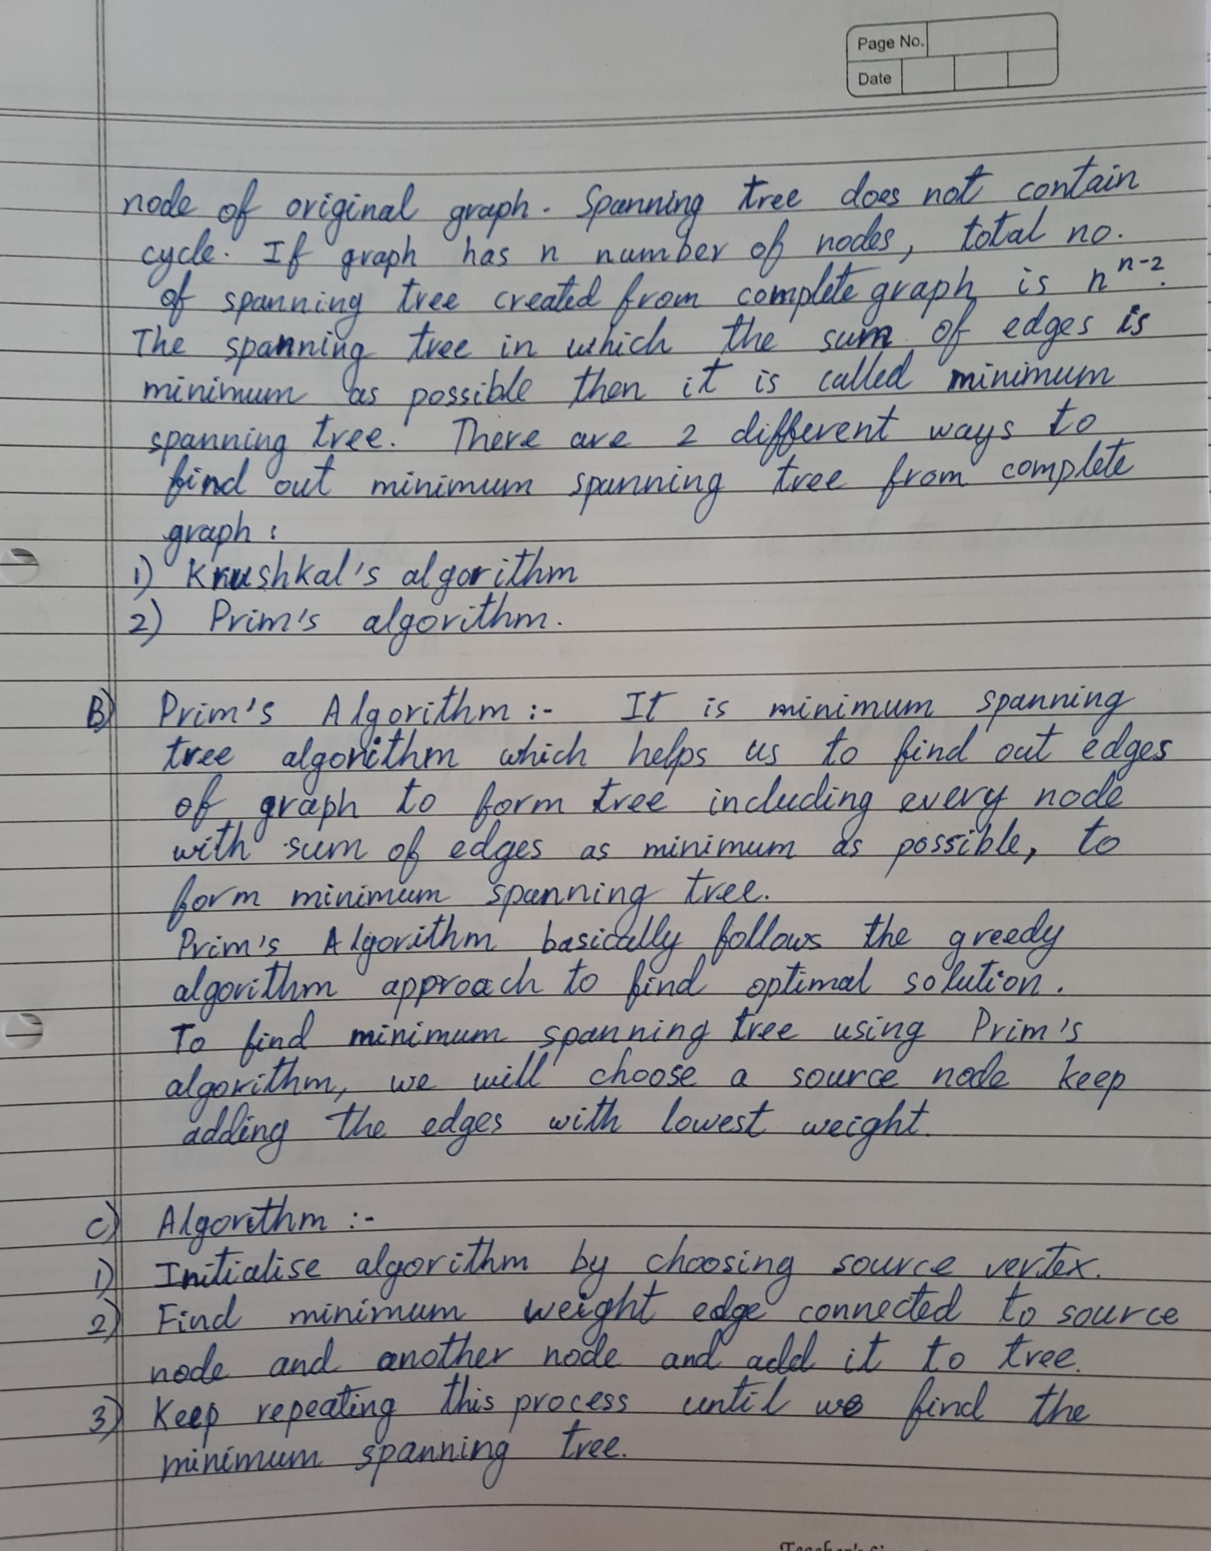

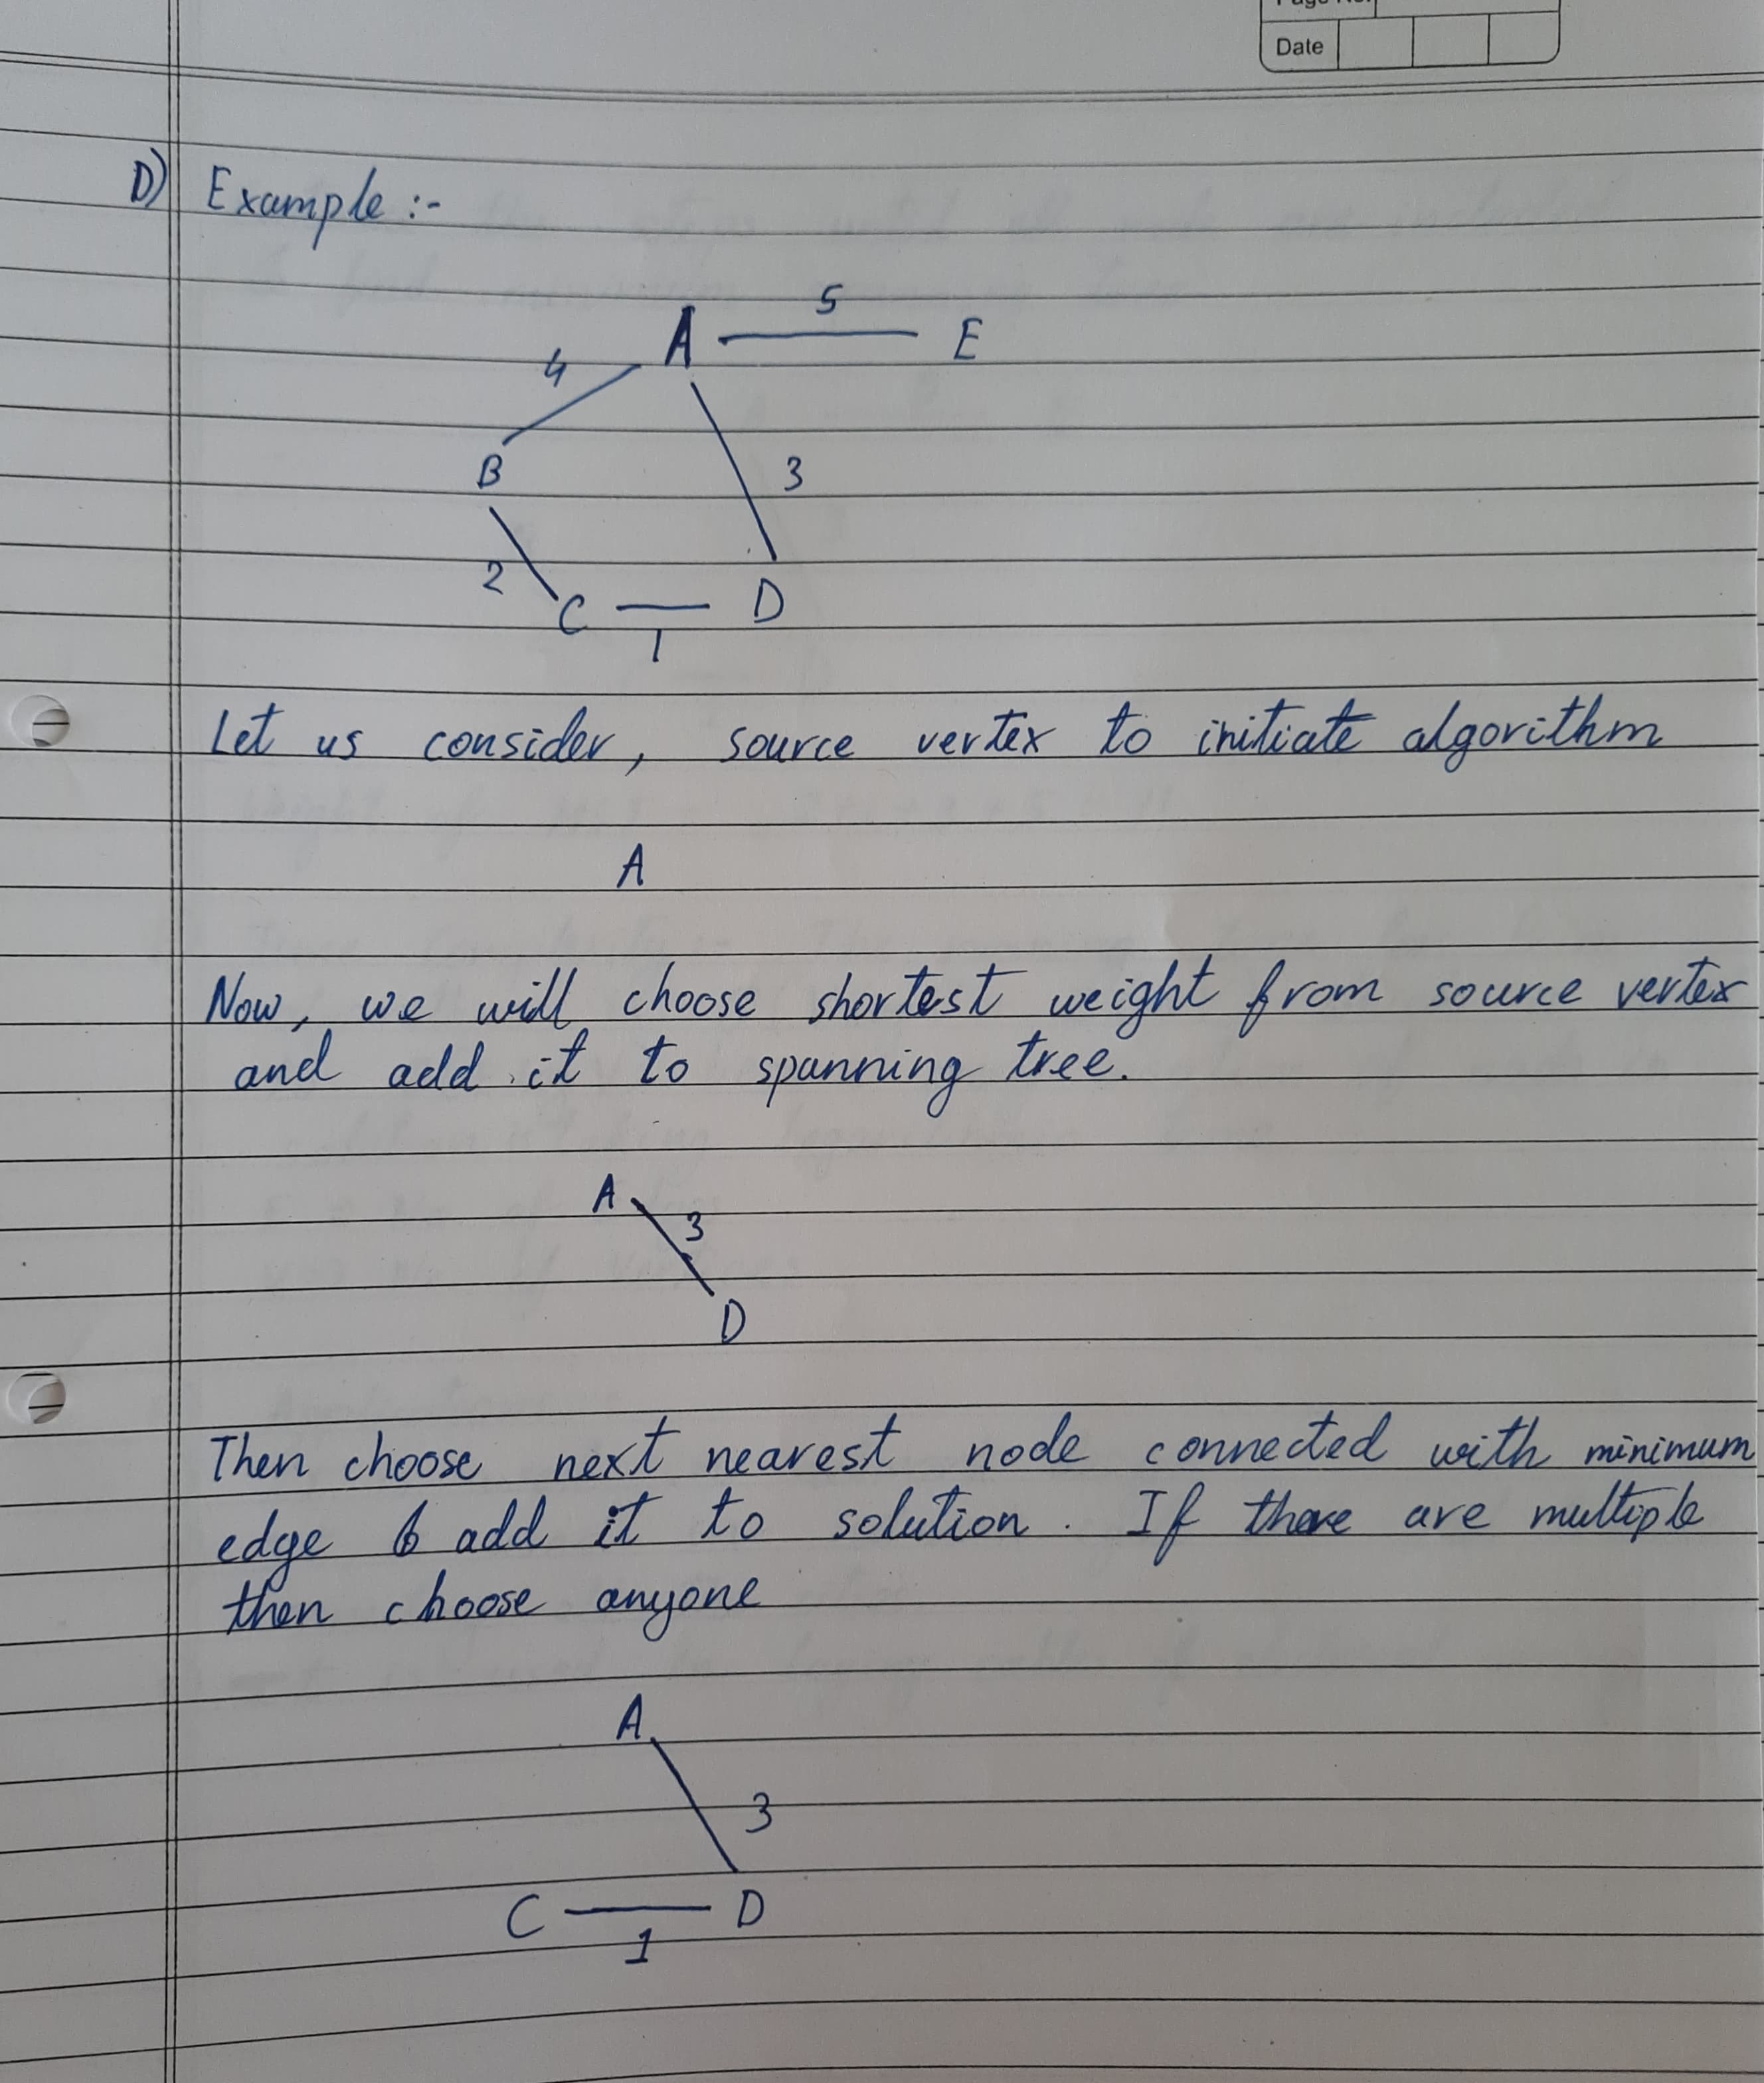

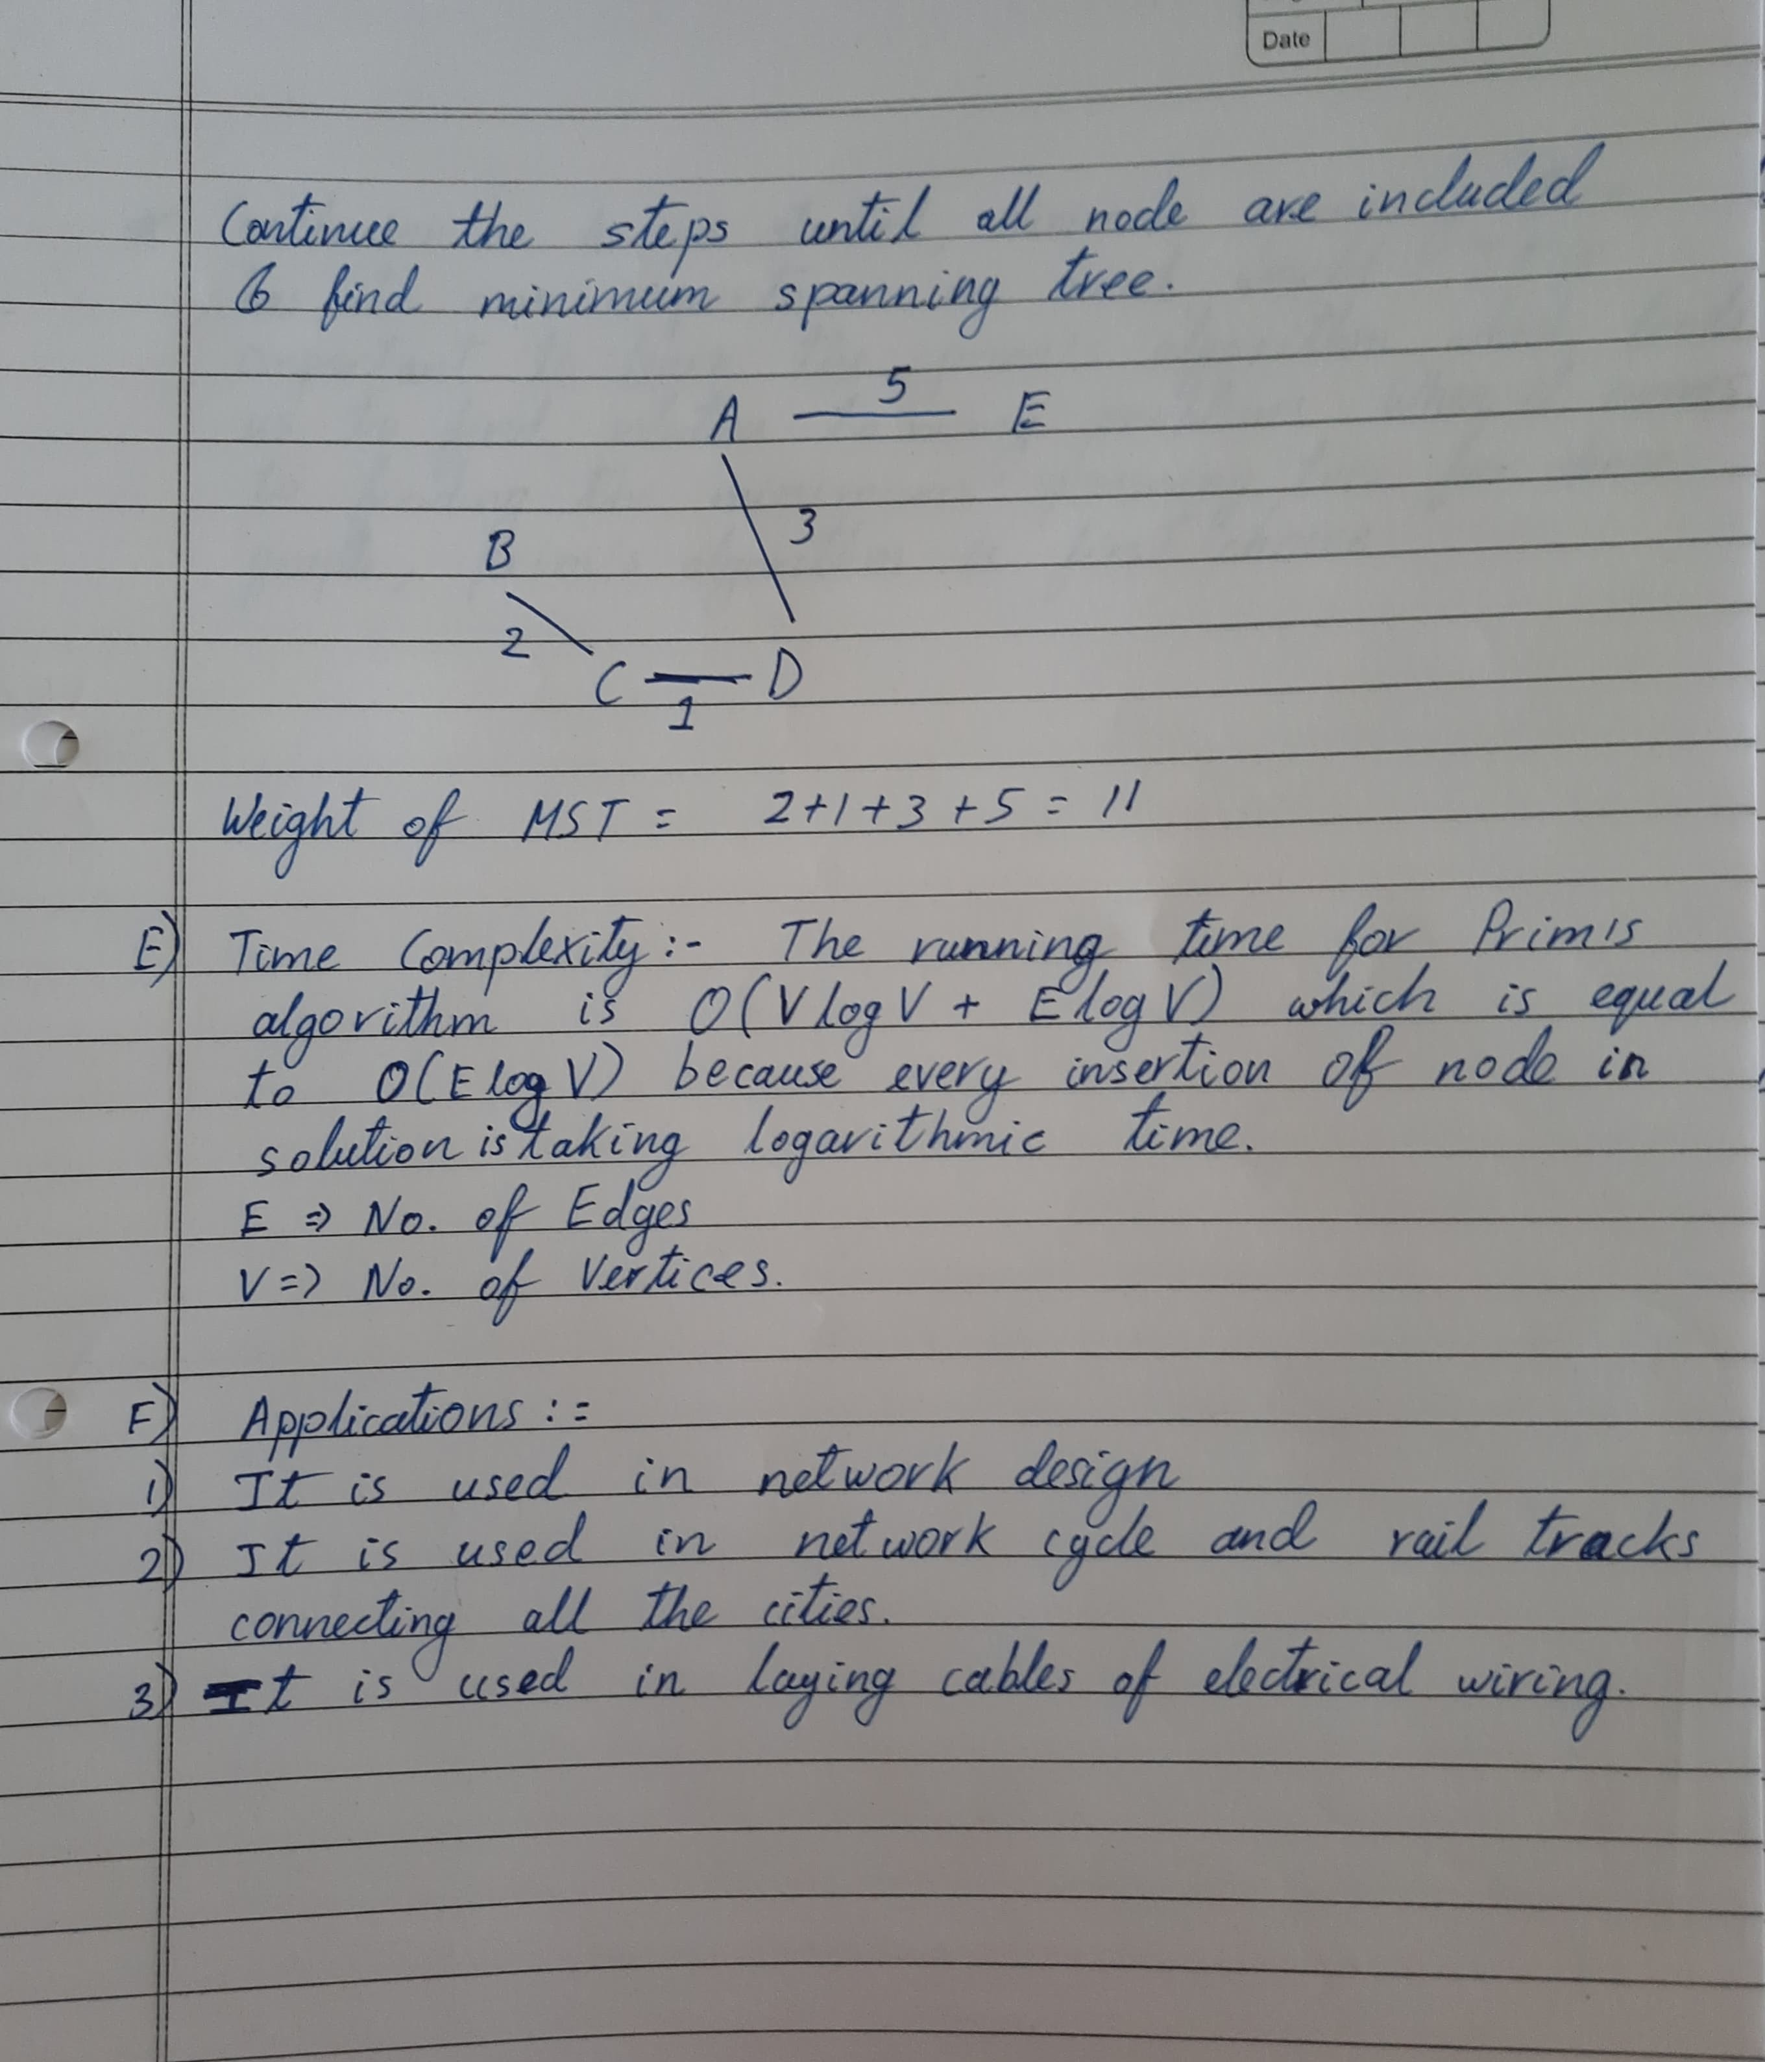

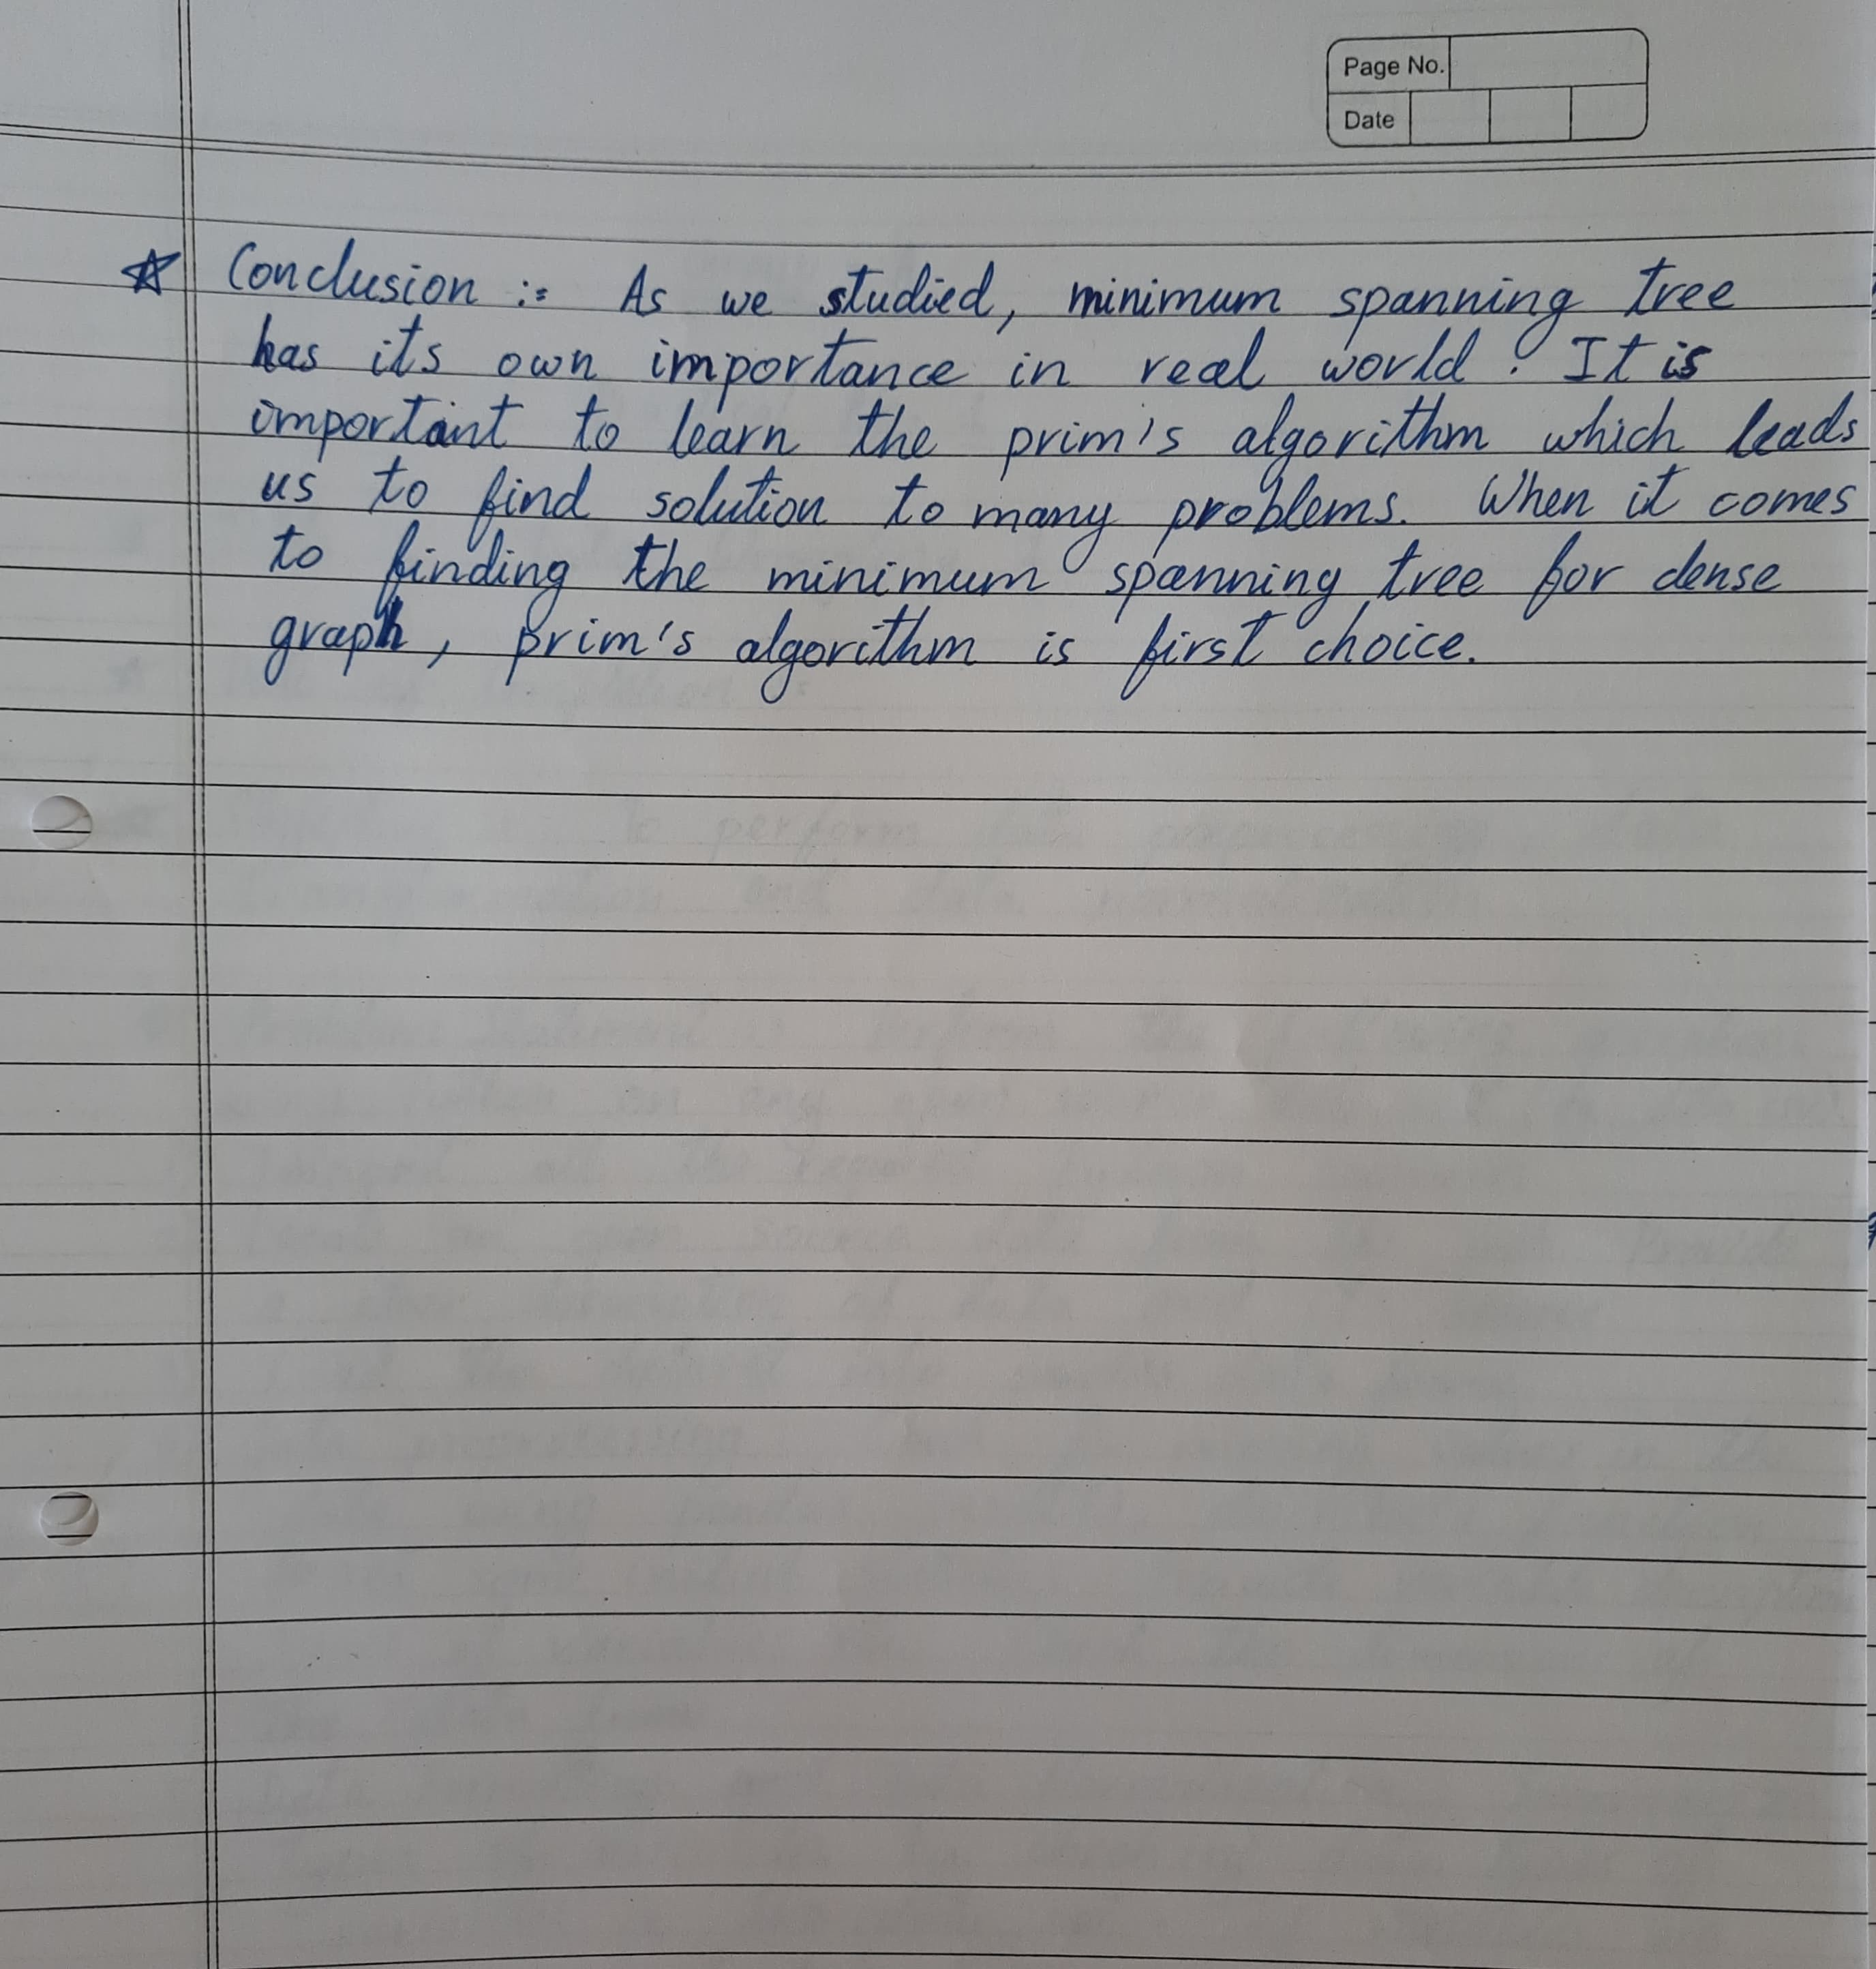

Practical No. A3

Que :- Implement Greedy search algorithm for any of the following application:

Prim's Minimal Spanning Tree Algorithm

Solution :-

Input =>

#include <bits/stdc++.h>

using namespace std;

#define V 5

int minKey(int key[], bool mstSet[]) {

int min = INT_MAX, min_index;

for (int v = 0; v < V; v++)

if (mstSet[v] == false && key[v] < min)

min = key[v], min_index = v;

return min_index;

}

void printMST(int parent[], int graph[V][V]) {

cout<<"Edge \tWeight\n";

for (int i = 1; i < V; i++)

cout<<parent[i]<<" - "<<i<<" \t"<<graph[i][parent[i]]<<" \n";

}

void primMST(int graph[V][V]) {

int parent[V];

int key[V];

bool mstSet[V];

for (int i = 0; i < V; i++)

key[i] = INT_MAX, mstSet[i] = false;

key[0] = 0;

parent[0] = -1;

for (int count = 0; count < V - 1; count++){

int u = minKey(key, mstSet);

mstSet[u] = true;

for (int v = 0; v < V; v++)

if (graph[u][v] && mstSet[v] == false && graph[u][v] < key[v])

parent[v] = u, key[v] = graph[u][v];

}

printMST(parent, graph);

}

int main() {

int graph[V][V] = { { 0, 2, 0, 6, 0 },

{ 2, 0, 3, 8, 5 },

{ 0, 3, 0, 0, 7 },

{ 6, 8, 0, 0, 9 },

{ 0, 5, 7, 9, 0 } };

primMST(graph);

return 0;

}

Output =>

